C-172 N | N – 737RR |  | July 9 2000 Wt & Bal Empty Weight 1481 ibs  ARM 38.44 inches  Moment 56929.2
Date:
PIC: |  |  | Weight (lbs) | Arm (in.) | Moment (in./lbs)

Aircraft Basic Empty Weight
Usable Fuel (40 Gal x6 lbs/gal) | + | x 48.0 | +
Pilot and Copilot | + | x 37.0 | +
Rear Passengers | + | x 73.0 | +
*Baggage Area 1 (120 lbs Max) | + | x 95.0 | +
*Baggage Area 2 (50 lbs Max) | + | x 123.0 | +
Start, Taxi, Runup Fuel | -7.0 | x 48.0 | - 336
Takeoff Weight / CG / Moment
Planned Flight Fuel Usage  (9 gals per hour) | - | x 48.0 | -
Landing Weight / CG / Moment

NOTE: *The maximum allowable combined weight capacity for baggage areas 1 and 2 is 120 lbs.

CG (in) = Sum of Moments / Sum of Weights

Write Takeoff and Landing CG in Arm Column Above, Mark on Diagram Below

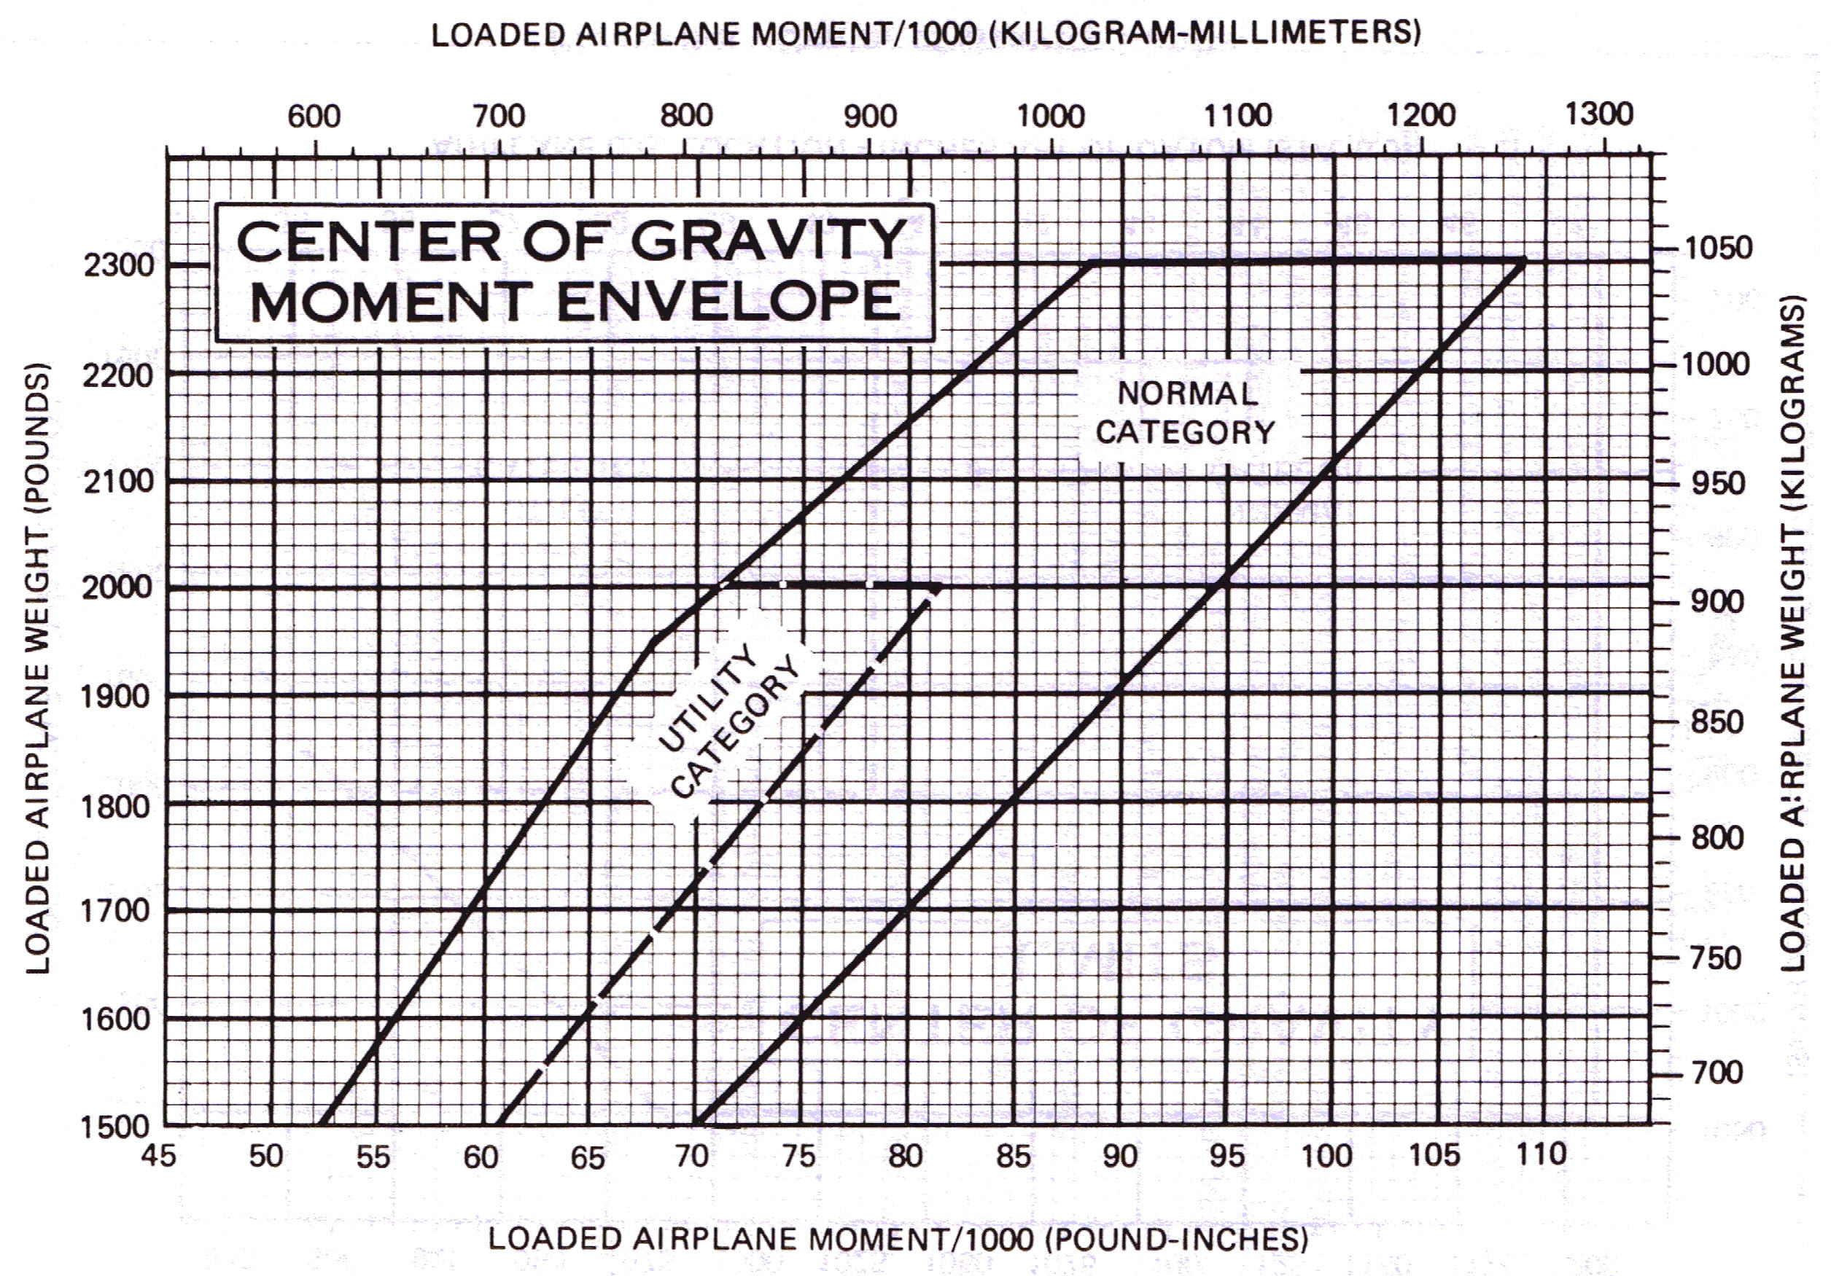

C-172N | N - | Temp: | PA:
TO Dist: |  | Land Dist:

TAKEOFF DISTANCE
maximum weight 2400 lbs

short field
CONDITIONS:
Flaps Up
Full Throttle Prior to Brake Release
Paved. Level, Dry Runway
Zero Wind

NOTES:
- Short field technique as specified in Section 4.
- Prior to takeoff fields above 3000 feet elevation, the mixture should be leaned to give maximum RPM in a full throttle, static runup.
- Decrease distance 10% for each 9 knots headwind. For operation with tailwinds up to 10 knots, increase distances by 10% for each 2 knots.
- For operation on a dry, grass runway, increase distance by 15% of the “ground roll” figure.

weight lbs | takeoff speed kias |  | press alt  ft | 0⁰C |  | 10⁰C |  | 20⁰C |  | 30⁰C |  | 40⁰C
weight lbs | lift off | at  50 ft | press alt  ft | grnd roll | total to clear 50 ft obs | grnd roll | total to clear 50 ft obs | grnd roll | total to clear 50 ft obs | grnd roll | total to clear 50 ft obs | grnd roll | total to clear 50 ft obs
2400 | 51 | 56 | S.L.  1000  2000  3000  4000  5000  6000  7000  8000 | 795  875  960  1055  1165  1285  1425  1580  1755 | 1460  1605  1770  1960  2185  2445  2755  3140  3615 | 860  940  1035  1140  1260  1390  1540  1710  1905 | 1570  1725  1910  2120  2365  2660  3015  3450  4015 | 925  1015  1115  1230  1355  1500  1665  1850  2060 | 1685  1860  2060  2295  2570  2895  3300  3805  4480 | 995  1090  1200  1325  1465  1620  1800  2000  ----- | 1810  2000  2220  2480  2790  3160  3620  4220  ----- | 1065  1170  1290  1425  1575  1745  1940  -----  ----- | 1945  2155  2395  2685  3030  3455  3990  -----  -----

LANDING DISTANCE

short field
CONDITIONS:
Flaps 30⁰ Power Off Maximum Breaking Paved. Level, Dry Runway Zero Wind

NOTES:
- Short field technique as specified in Section 4.
- Decrease distance 10% for each 9 knots headwind. For operation with tailwinds up to 10 knots, increase distances by 10% for each 2 knots.
- For operation on a dry, grass runway, increase distance by 45% of the “ground roll” figure.
- If a landing with flaps up is necessary, increase the approach speed by 7 KIAS and allow for 35% longer distance.

weight lbs | speed at  50 ft kias | press alt  ft | 0⁰C |  | 10⁰C |  | 20⁰C |  | 30⁰C |  | 40⁰C
weight lbs | speed at  50 ft kias | press alt  ft | grnd roll | total to clear 50 ft obs | grnd roll | total to clear 50 ft obs | grnd roll | total to clear 50 ft obs | grnd roll | total to clear 50 ft obs | grnd roll | total to clear 50 ft obs
2400 | 61 | S.L.  1000  2000  3000  4000  5000  6000  7000  8000 | 510  530  550  570  595  615  640  665  690 | 1235  1265  1295  1330  1365  1400  1435  1475  1515 | 530  550  570  590  615  640  660  690  715 | 1265  1295  1330  1360  1400  1435  1470  1515  1555 | 550  570  590  615  635  660  685  710  740 | 1295  1325  1360  1395  1430  1470  1510  1550  1595 | 570  590  610  635  660  685  710  735  765 | 1325  1360  1390  1430  1470  1510  1550  1590  1635 | 585  610  630  655  680  705  730  760  790 | 1350  1390  1425  1460  1500  1540  1580  1630  1675

